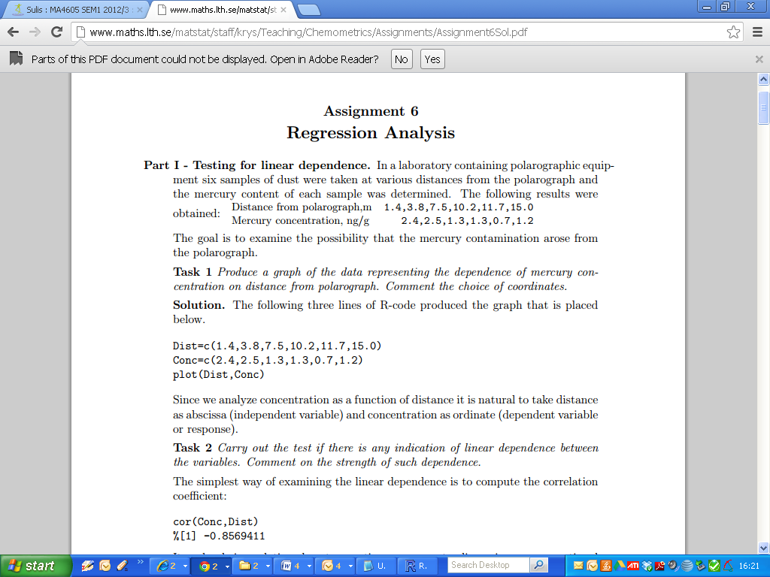

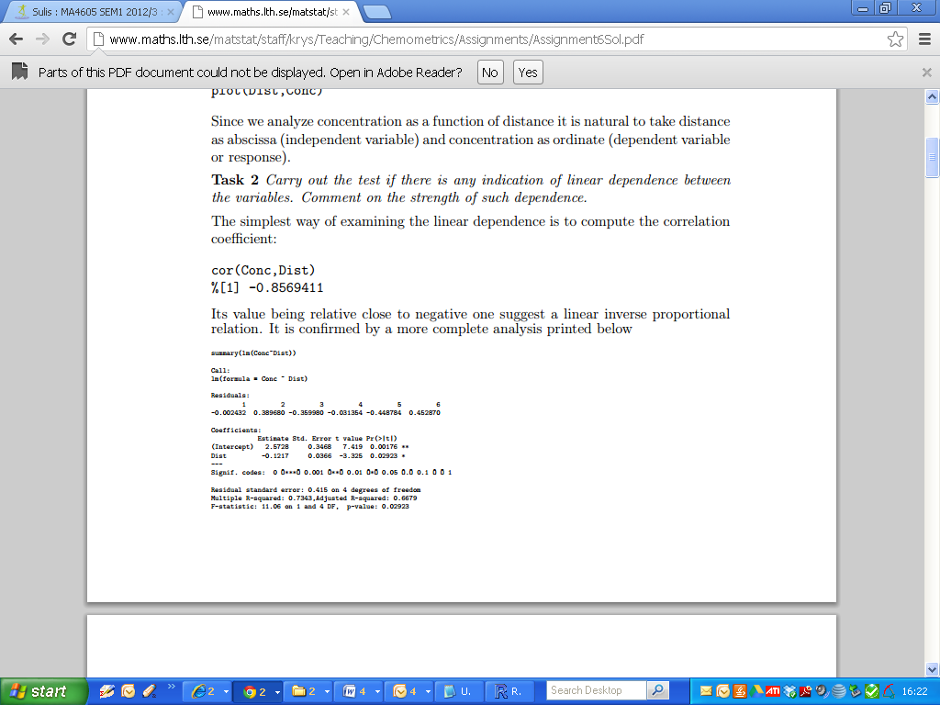



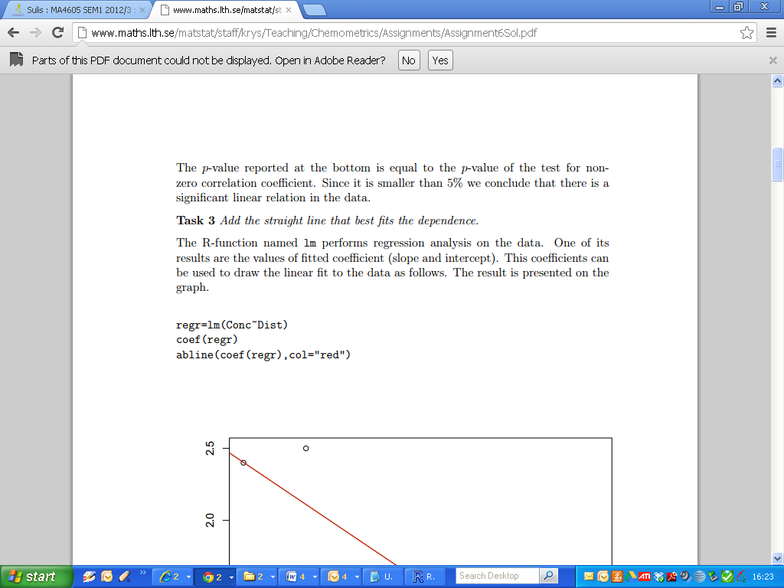

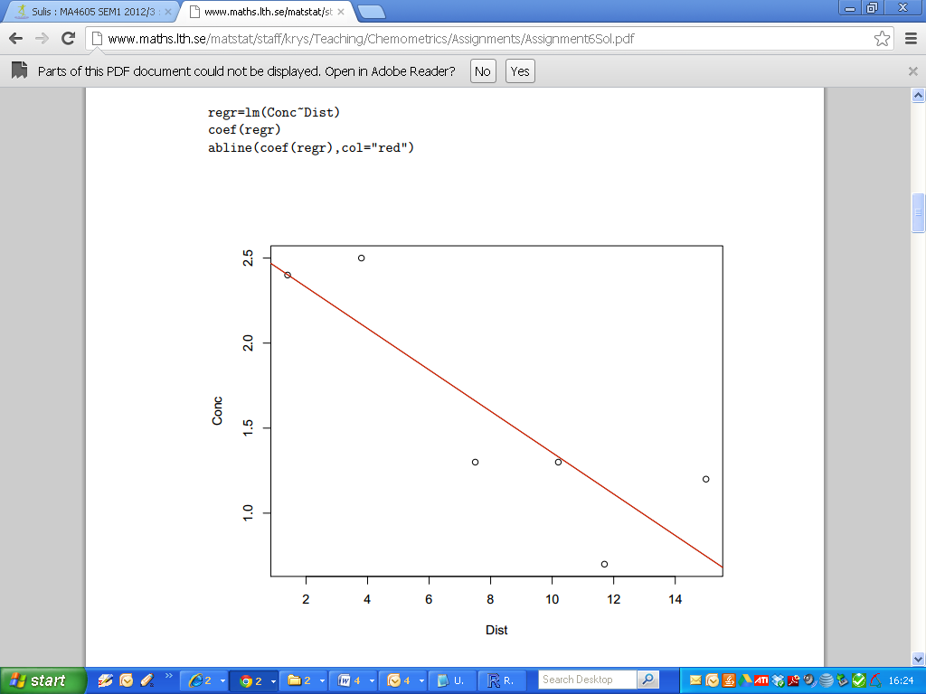

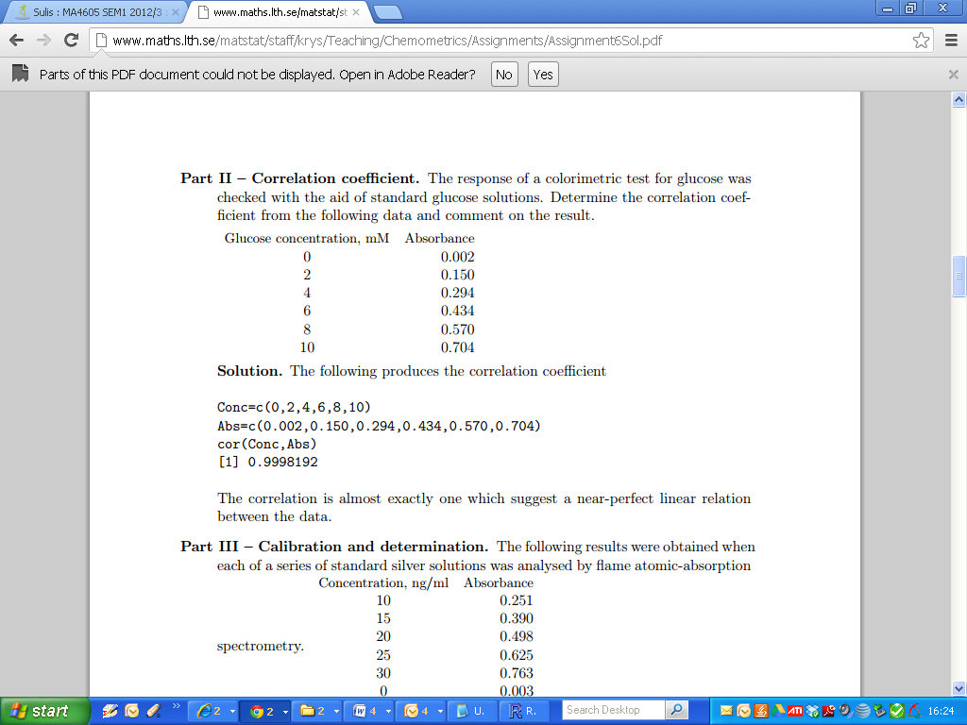

|  |
| --- |
| > Gluc = c(0,2,4,6,8,10)  > Absrb = c(0.002,0.15,0.294,0.434,0.57,0.704)  >  > cor.test(Absrb,Gluc)  Pearson's product-moment correlation  data: Absrb and Gluc  t = 105.1606, df = 4, p-value = 4.903e-08  alternative hypothesis: true correlation is not equal to 0  95 percent confidence interval:  0.9982632 0.9999812  sample estimates:  cor  0.9998192 |

The Correlation is almost exactly one, which suggests a near-perfect linear relationship.

The p-value and confidence intervals are also highlighted, in purple.

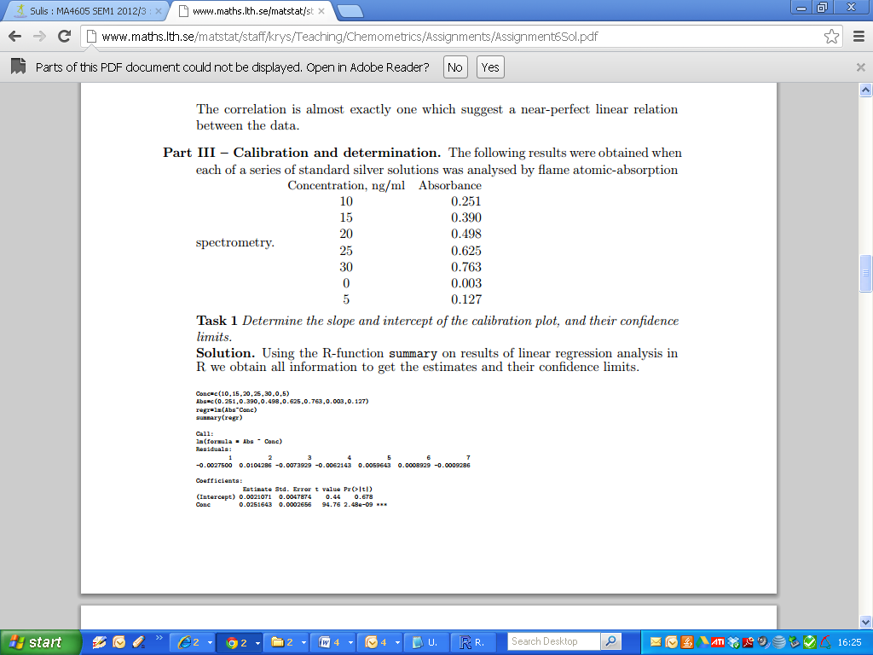

|  |
| --- |
| Conc=c(0,15,20,25,30,0,5)  Abso=c(0.251,0.390,0.498,0.625,0.763,0.003,0.127)  Fit4 = lm(Abso ~ Conc) |

|  |
| --- |
| Fit4  confint(Fit4)  summary(Fit4) |

|  |
| --- |
| > Fit4  Call:  lm(formula = Absrb ~ Gold)  Coefficients:  (Intercept) Gold  0.256917 0.005349  > confint(Fit4)  2.5 % 97.5 %  (Intercept) 0.25108226 0.262751077  Gold 0.00520934 0.005488279 |

The regression equation is

Absrb.fitted = 0.257 + 0.0054 Gold

The 95% confidence intervals for the regression coefficients are

Intercept β0: (0.2516,0.263)

Slope β1 :(0.00520, 0.005488)

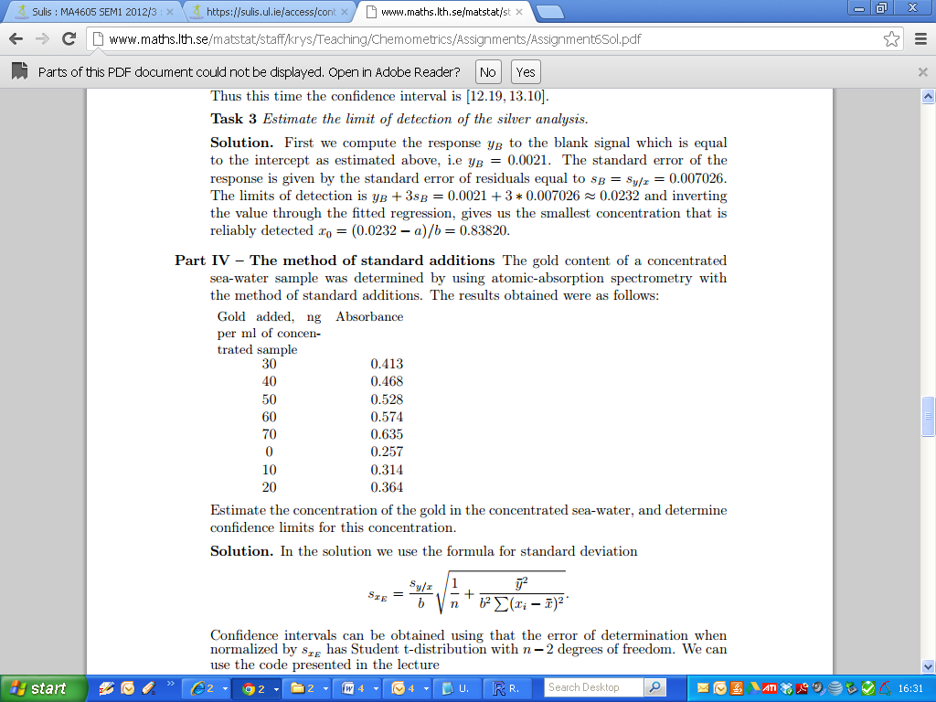

|  |
| --- |
| > Gold = c(30,40,50,60,70,0,10,20)  > Absrb= c(0.413,0.468,0.528,0.574,0.635,0.257,0.314,0.364)  > Fit4 = lm(Absrb ~ Gold)  >  > summary(Fit4)  Call:  lm(formula = Absrb ~ Gold)  Residuals:  Min 1Q Median 3Q Max  -0.0043810 -0.0031131 0.0000952 0.0036071 0.0036667  Coefficients:  Estimate Std. Error t value Pr(>|t|)  (Intercept) 0.256917 0.002384 107.75 4.31e-11 ***  Gold 0.005349 0.000057 93.84 9.87e-11 ***  ---  Signif. codes: 0 ‘***’ 0.001 ‘**’ 0.01 ‘*’ 0.05 ‘.’ 0.1 ‘ ’ 1  Residual standard error: 0.003694 on 6 degrees of freedom  Multiple R-squared: 0.9993, Adjusted R-squared: 0.9992  F-statistic: 8806 on 1 and 6 DF, p-value: 9.866e-11 |

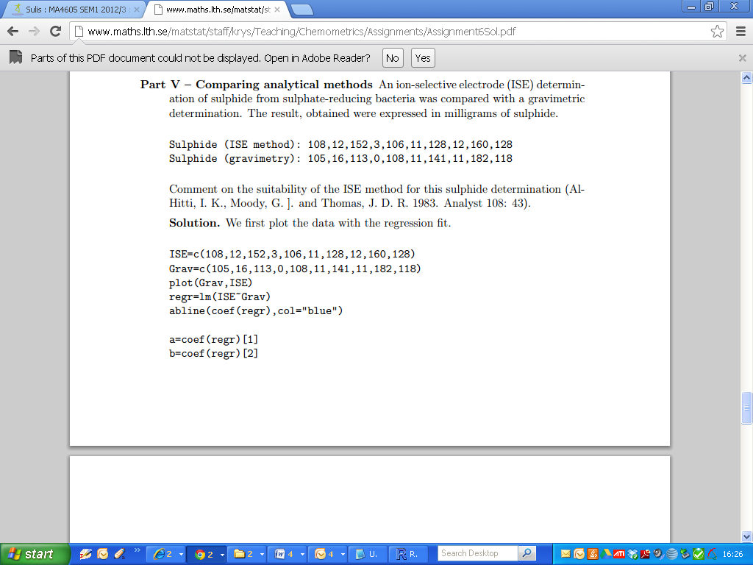

|  |
| --- |
|  |

Lab C part 5

|  |
| --- |
|  |

|  |
| --- |
| > Fit5a  Call:  lm(formula = ISE ~ Grav)  Coefficients:  (Intercept) Grav  4.4837 0.9629 |

|  |
| --- |
| > Fit5b  Call:  lm(formula = Grav ~ ISE)  Coefficients:  (Intercept) ISE  0.4195 0.9766 |

There is a disparity in what both linear models predict.

A predicted value of ISE based on a known value of GRAV can be easily determined.

Grav = 4.4837 + 0.9629(10)

ISE.fitted = 4.4837 + 0.9629 Grav

Suppose Grav is 10. The fitted value of ISE, using Fit5a = 14.1127

Let’s use Fit5b to predict a value for ISE = 14. If we are to believe Fit5a, the answer should be roughly 10.

Using Fit5b, we get a predicted value of 14.20196 for grav.fitted.

Hence the use of Linear models is invalid when comparing methods of measurement.